## Conclusion

## By conducting experiments with BERT on news data, primarily focusing on alert-like news data as mentioned in the paper, we have achieved promising results. The primary challenges we encountered revolve around the data source.

## Input Data

## Minute-level timestamped news data and minute-level timestamped price data are essential for this study. I employed the news data presented in the ACL 2023 main conference paper titled "Causality-Guided Multi-Memory Interaction Network for Multivariate Stock Price Movement Prediction." To replicate the paper's input, I merged the news titles and summaries, creating a text input. The price data was sourced from Yahoo Finance. You can find an example of the input data below. For the experiment, I selected four prominent companies: Facebook (FB), Google (GOOG), Apple (AAPL), and Amazon (AMZN).

## Code

## You can review the [code](https://github.com/SITONGRUC/small_projects_of_sitongli/blob/main/report_for_prof/BERT/code.ipynb) here. It's straightforward and detailly commented. First, I utilized a tokenizer to preprocess the data, followed by applying the BERT model to compute and predict the price label. You can find the code here.

## It's important to note that there are several hyperparameters that need optimization. Due to budget constraints for GPU rental, the maximum token limit I used in this experiment was set to 64. However, it's worth mentioning that the results are remarkably close to what's presented in the paper, demonstrating the effectiveness of our approach. (And my resource is cheap in fact. It would only cost $3 to experiment many times)

## Output

Since it’s a deep learning model (nonlinear), we could not use R2. Instead, we use correlation as output. And we have the following result, showing that the result is close to paper shown. The reason for difference is mainly data and the token size. The paper is 512 but I use 64 for quicker hyperparameter experiment.

AAPL: Data example is [here](https://github.com/SITONGRUC/small_projects_of_sitongli/blob/main/report_for_prof/BERT/apple.csv) FaceBook

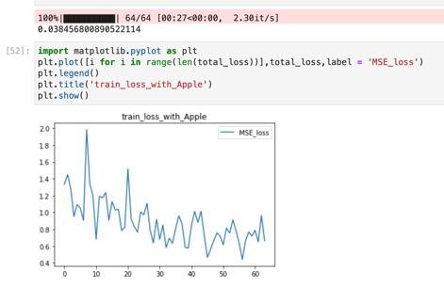

GOOGLE AMZN